Here is the new process for Credential Card Payment

Please go to https://everify.americanstatenationals.us/ Click on the Enter Button
Home - Everify for American State Nationals
You have entered a server of the government of The United States of America [Unincorporated] All accesses are logged. If you are an Authorized User, Peacekeeper, Sheriff or Law Enforcement Officer press the ENTER button below, if not exit now.
everify.americanstatenationals.us

Click on Locate/Verify Member Record and Enter your name.
Once you enter your name Click Submit. This will bring up your profile
Then click on Go To Record

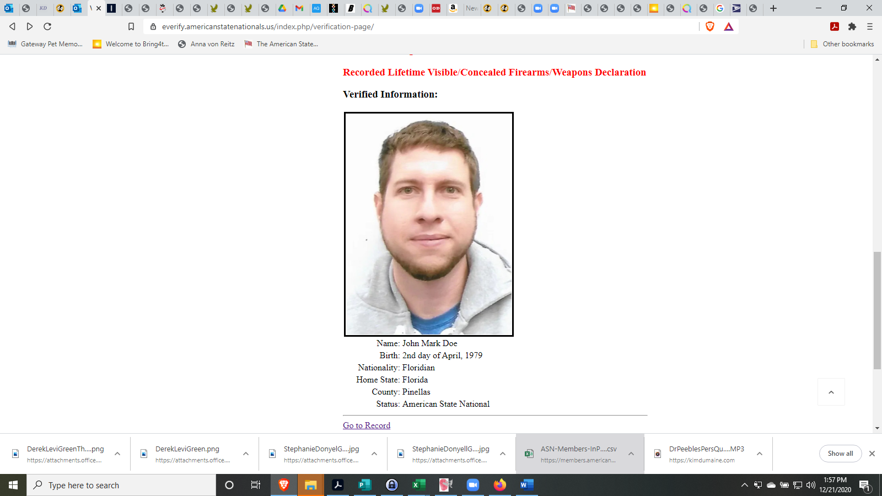

Click on the Fees Button up at the top and use the Paypal Button on the lower left to make payment. Change the Fee to Credential please! Thank you - Teri

